***Purpose***

Assess the influence of human-caused habitat disturbance, and climate change on Southern Mountain caribou population growth rates between 1980-2021. If possible, estimate levels at which influential variables likely precipitate population declines. We are not assessing the specific role of fire at this point becuase it is generally rare compared to other disturbances, but we will compare measures of disturbance with and without fire included.

***Necessary conditions***

We can estimate caribou population growth with reasonable precision. Climate and disturbance variables are correlated at r<0.6.

***Hypotheses to test***

**1.** Caribou are currently primarily limited by the direct effects of climate change (i.e., changing temperature, precipitation, etc) which renders their current biophysical habitat unsuitable due to being outside their climate envelope. The primary pathways (Figures 1, 2 and 3) for this hypothesis would include reduced nutritional and body condition because of increased temperature and drought, which would reduce survival and fecundity.

**a.** Assess caribou population growth under population management such as wolf reductions. If caribou can increase after lowering predation pressure, then the direct effects of climate change are not limiting growth. This does not exclude the role of indirect effects such as climate increasing deer and thus predators.

**b.** We’ve already done this in the submitted IPM paper. We can cite that paper and refute this hypothesis.

**2.** Caribou are currently primarily limited by the indirect effects of climate change, such that a changing climate has altered predator prey dynamics through increased alternate prey abundance in caribou habitat resulting in increased predation rates on caribou.

**a.** Herds with lower winter severity and thus more white-tailed deer, or with rapidly changing climates, or altered fire regimes, will be declining more rapidly than others. Human-caused disturbance (i.e., early seral caused by logging or agriculture) does not explain additional variation.

**b.** The overall caribou density in these more climate-impacted herds ought to be lower, after accounting for mean forest age and other factors that would set the overall caribou density. Climate effects may have been long-impacting caribou and thus we’d expect lower densities in the areas with more rapid climate velocities.

**3.** Caribou are currently limited by human-caused disturbance, such that the transformation of caribou habitat from mature forests to early seral conditions has altered predator prey dynamics through increased alternate prey abundance in caribou habitat resulting in increased predation rates on caribou

**a.** Herds with higher levels of disturbance (foresty and mining) should be decreasing more rapidly than those with less disturbance. Climate factors do not explain additional variation.

**4.** Caribou are currently limited by human-caused disturbance and the indirect effects of climate change, which collectively alter predator prey dynamics through increased alternate prey abundance in caribou habitat resulting in increased predation rates on caribou.

**a.** Herds with higher levels of disturbance, and lower winter severity or climates that are changing more rapidly than others, will be declining more rapidly than others.

***Data to use***

*Annual caribou demographic data-*Demographic data will come from the IPM. We will only consider data for each herd after their first survival or abundance estimate to reduce the influence of IPM estimates that are mostly from the priors. It may also be possible to do the analysis of climate and disturbance within the IPM itself. We will need to assess the viability of this option and pros/cons. This can be decided at a later date.

*Annual disturbance variables*- polygonal disturbances such as mines, forest harvest, wildfire, and pest infestations have been reliably time stamped annually. We have access to these data for BC and AB, which were combined into a single dataset by ECCC. Linear features such as roads or pipelines have not been reliably time stamped. For this reason, we will only focus on polygonal disturbances, which we believe have the greatest effect on caribou through numeric responses in predators and prey. Linear features may also contribute via a functional response and small numeric response (Figs 1:3), and we will have to acknowledge that these features also likely increased through time but we do not include them. We will assess the configuration of disturbance using the R implementation of FRAGSTATS (landscapemetrics).

*Annual climate variables-* We have access to gridded annual climate data back to 1980 via Daymet 4. These data include daily weather variables such as temperature, precipitation, and snow water equivalent of the snowpack. We can also access snow depth from the ERA5-Land monthly averaged data from 1981 to present. We will estimate winter severity between December 1 and April 30 by adding the number of days with 45 cm or more snow depth to the number of days when the minimum temperatures were below -18°C. We will create a composite measure of annual climate using a PCA to identify precipitation and temperature axes that can parse out warm and dry vs cool and moist.

***Analysis***

The analysis will ultimately use the results from the 40 herd SMC caribou IPM, but how it’s implemented is a topic for discussion. We can:

1) regress the annual covariates against the derived posterior distributions of annual population growth rate from the IPM in a multiple competing mixed model framework based on the hypotheses above. If possible we would specifiy this mixed model with a random slope and intercept for each herd.

2) Similar to 1, we can use the outputs of the IPM, but instead of the derived annual population growth (Nt/ Nt-1), we could use N explicitly. The analysis would be similar to (Lochhead et al. 2022), where we’d fit non linear mixed effects models to abundance—or density if we’re interested in more than just how abundance changes through time—and assess the influence of covariates on changes in abundances through time.

3) Include the covariates above directly in the IPM as linear predictors on survival and recruitment. Most folks will think this is the most elegant approach.

I propose we begin with analysis #3 and I have made strides in doing so.

***Additional considerations***

The covariates need to be summarized over space for each herd. As a first pass we will use the provincially-defined herd boundaries. But we will also explore, if possible, delineating herd ranges using available telemetry data. The telemetry approach will more directly reflect the area actually used by caribou. We will assess the influence of surrounding habitat beyond what is directly underfoot for the caribou by adding buffers to these animal-defined ranges.

***Tal’s DAGS:***

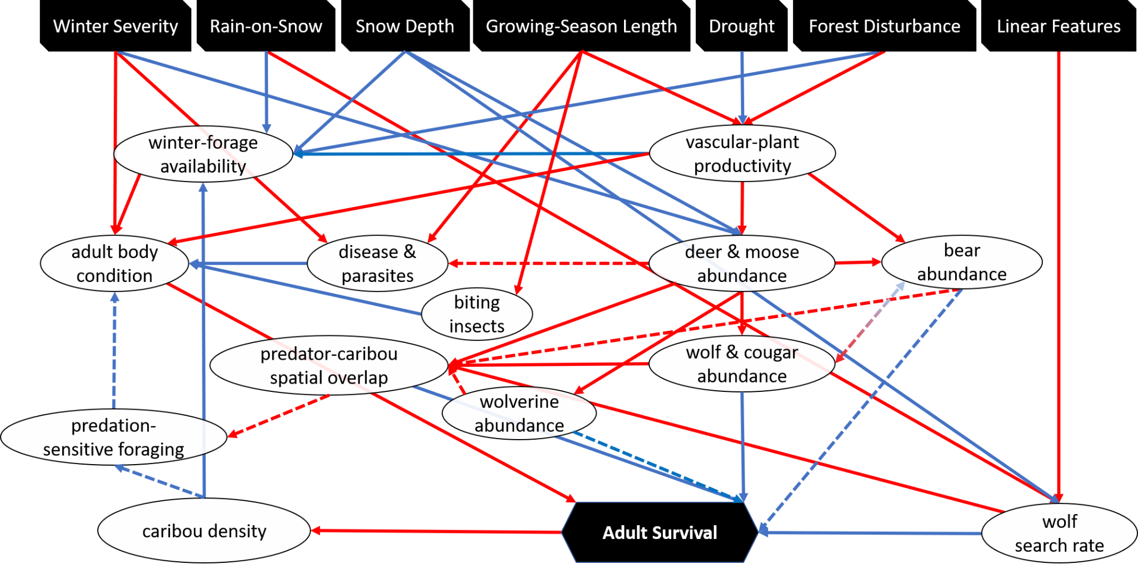

Figure 1. Mechanistic pathways between the environment and caribou adult survival. Red arrows represent positive effects (i.e., an increase in the source node leads to an increase in the outcome node), blue arrows represent negative effects (an increase in the source node leads to an decrease in the outcome node), dashed arrows reflect high uncertainty in the importance of the effect, and double-edged arrows reflect two-sided relationships.

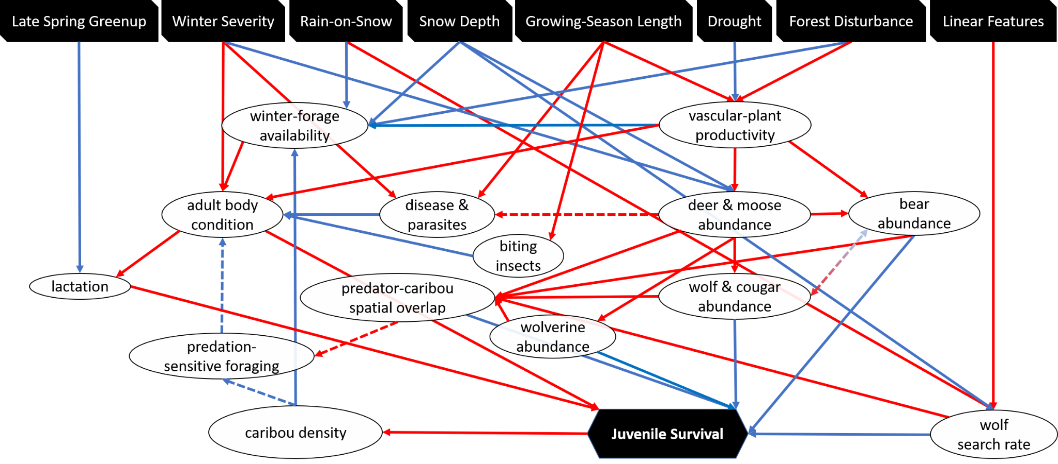

Figure 2. Mechanistic pathways between the environment and caribou juvenile survival

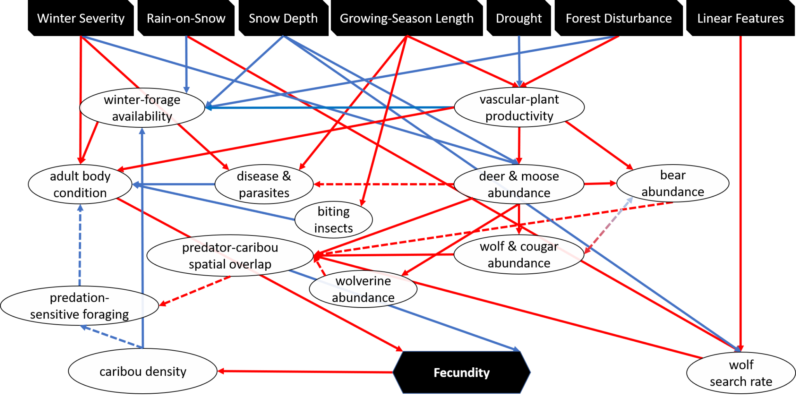

Figure 3. Mechanistic pathways between the environment and caribou fecundity (pregnancy and parturition success).